1. Write a R program to create a list of elements using vectors, matrices and a functions. Print the content of the list.
l = list( c(1, 2, 2, 5, 7, 12),
month.abb,
matrix(c(3, -8, 1, -3), nrow = 2),
asin)
print("Content of the list:")
print(l)
2. Write a R program to get the unique elements of a given string and unique numbers of vector.
str1 = "The quick brown fox jumps over the lazy dog."
print("Original vector(string)")
print(str1)
print("Unique elements of the said vector:")
print(unique(tolower(str1)))
nums = c(1, 2, 2, 3, 4, 4, 5, 6)
print("Original vector(number)")
print(nums)
print("Unique elements of the said vector:")
print(unique(nums))

3. Write a R program to extract first 10 english letter in lower case and last 10 letters in upper case and extract letters between 22nd to 24th letters in upper case
print("First 10 letters in lower case:")
t = head(letters, 10)
print(t)
print("Last 10 letters in upper case:")
t = tail(LETTERS, 10)
print(t)
print("Letters between 22nd to 24th letters in upper case:")
e = tail(LETTERS[22:24])
print(e)
4. Write a R program to create three vectors a,b,c with 3 integers. Combine the three vectors to become a 3×3 matrix where each column represents a vector. Print the content of the matrix.
a<-c(1,2,3)
b<-c(4,5,6)
c<-c(7,8,9)
m<-cbind(a,b,c)
print("Content of the said matrix:")
print(m)
5. Write a R program to create an array, passing in a vector of values and a vector of dimensions. Also provide names for each dimension.
a = array(
6:30,
dim = c(4, 3, 2),
dimnames = list(
c("Col1", "Col2", "Col3", "Col4"),
c("Row1", "Row2", "Row3"),
c("Part1", "Part2")
)
)
print(a)
6. Write a R program to create a list of elements using vectors, matrices and a functions. Print the content of the list
l = list(
c(1, 2, 2, 5, 7, 12),
month.abb,
matrix(c(3, -8, 1, -3), nrow = 2),
asin
)
print("Content of the list:")
print(l)
7. Write a R program to create a Data Frames which contain details of 5 employees and display summary of the data
Employees = data.frame(Name=c("Anastasia S","Dima R","Katherine S", "JAMES A","LAURA MARTIN"),
Gender=c("M","M","F","F","M"),
Age=c(23,22,25,26,32),
Designation=c("Clerk","Manager","Exective","CEO","ASSISTANT"),
SSN=c("123-34-2346","123-44-779","556-24-433","123-98-987","679-77-576")
)
print("Summary of the data:")
print(summary(Employees))

8. Write a R program to create a two-dimensional 5x3 array of sequence of even integers greater than 50.
a <- array(seq(from = 50, length.out = 15, by = 2), c(5, 3))
print("Content of the array:")
print("5×3 array of sequence of even integers greater than 50:")
print(a)
9. Write a R program to find elements which are present in two given data frames
a = c("a", "b", "c", "d", "e")
b = c("d", "e", "f", "g")
print("Original Dataframes")
print(a)
print(b)
print("Elements which are present in both dataframe:")
result = intersect(a, b)
print(result)
10. Write a R program to find elements come only once that are common to both given data frames.
a = c("a", "b", "c", "d", "e")
b = c("d", "e", "f", "g")
print("Original Dataframes")
print(a)
print(b)
print("Find elements come only once that are common to both given dataframes:")
result = union(a, b)
print(result)
11. Write a R program to count the number of NA values in a data frame column
exam_data = data.frame(
name = c('Anastasia', 'Dima', 'Katherine', 'James', 'Emily', 'Michael', 'Matthew', 'Laura', 'Kevin', 'Jonas'),
score = c(12.5, 9, 16.5, 12, 9, 20, 14.5, 13.5, 8, 19),
attempts = c(1, NA, 2, NA, 2, NA, 1, NA, 2, 1),
qualify = c('yes', 'no', 'yes', 'no', 'no', 'yes', 'yes', 'no', 'no', 'yes')
)
print("Original dataframe:")
print(exam_data)
print("The number of NA values in attempts column:")
print(sum(is.na(exam_data$attempts)))
12. Write a R program to create a data frame using two given vectors and display the duplicated elements and unique rows of the said data frame
a = c(10,20,10,10,40,50,20,30)
b = c(10,30,10,20,0,50,30,30)
print("Original data frame:")
ab = data.frame(a,b)
print(ab)
print("Duplicate elements of the said data frame:")
print(duplicated(ab))
print("Unique rows of the said data frame:")
print(unique(ab))
13. Write a R program to call the (built-in) dataset airquality. Check whether it is a data frame or not? Order the entire data frame by the first and second column.
data = airquality
print("Original data: Daily air quality measurements in New York, May to September 1973.")
print(class(data))
print(head(data,10))
result = data[order(data[,1]),]
print("Order the entire data frame by the first and second column:")
print(result)

14. Write a R program to assign new names "a", "b" and "c" to the elements of a given list
list1 = list(g1 = 1:10, g2 = "R Programming", g3 = "HTML")
print("Original list:")
print(list1)
names(list1) = c("one", "two", "three")
print("Assign new names 'one', 'two' and 'three' to the elements of the said list")
print(list1)

15. Write a R program to get the length of the first two vectors of a given list.
list1 = list(g1 = 1:10, g2 = "R Programming", g3 = "HTML")
print("Original list:")
print(list1)
print("Length of the vector 'g1' and 'g2' of the said list")
print(length(list1$g1))
print(length(list1$g2))

16. Write a R program to find all elements of a given list that are not in another given list.
l1 = list("x", "y", "z")
l2 = list("X", "Y", "Z", "x", "y", "z")
print("Original lists:")
print(l1)
print(l2)
print("All elements of l2 that are not in l1:")
setdiff(l2, l1)

17. Write a R program to create a factor corresponding to height of women data set, which contains height and weights for a sample of women.
data = women
print("Women data set of height and weights:")
print(data)
height_f = cut(women$height,3)
print("Factor corresponding to height:")
print(table(height_f))

18. Find 10 random numbers between 0 and 100, rounded to the nearest whole number (Hint: you can use either sample or a combination of round and runif).
# sample
sample(0:100,10)
## [1] 42 66 73 71 48 30 63 91 1 13
# runif and round round(runif(10, 0, 100), 0)
## [1] 23 65 30 24 92 6 38 73 71 36
19. Create a vector of the values of e^{x} cos(x) at x = 3, 3.1, 3.2, . . . , 6.
20. Execute the following lines which create two vectors of random integers which are chosen with replacement from the integers 0, 1, . . . , 999. Both vectors have length 250.
set.seed(50)
xVec <- sample(0:999, 250, replace=T) yVec <- sample(0:999, 250, replace=T)
Suppose x = (x1, x2, . . . , xn) denotes the vector xVec and y = (y1, y2, . . . , yn) denotes the vector yVec.
(a) Create the vector (y2 − x1, . . . , yn − xn−1).
(b) Create the vector
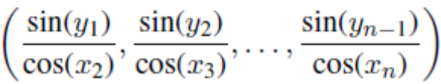.
(c) Create the vector (x1 + 2x2 − x3, x2 + 2x3 − x4, . . . , xn−2 + 2xn−1 − xn).
(d) Calculate
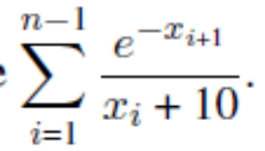
21. Create the following patterned matrices. In each case, your solution should make use of the special form of the matrix—this means that the solution should easily generalise to creating a larger matrix with the same structure and should not involve typing in all the entries in the matrix.
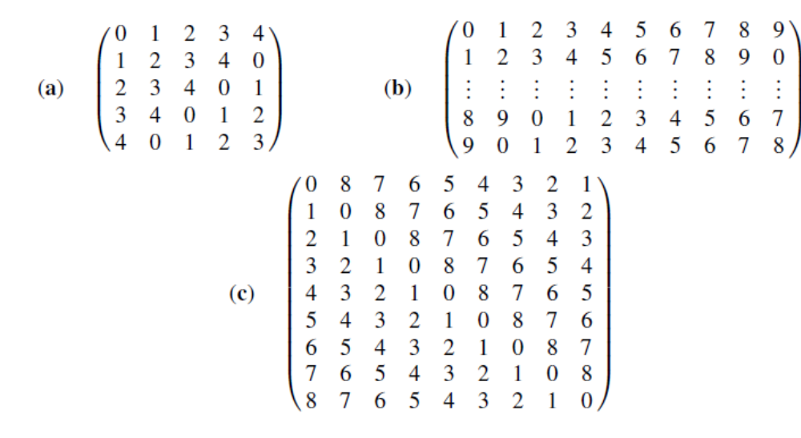
22. Solve the following system of linear equations in five unknowns
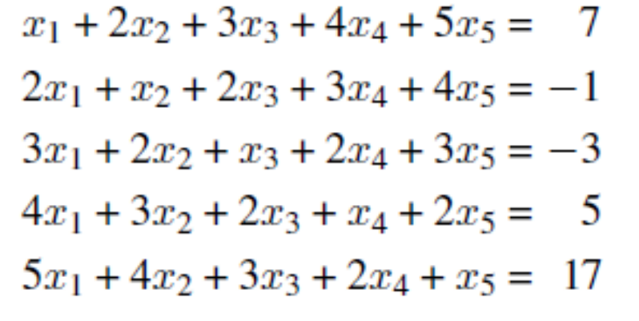
by considering an appropriate matrix equation Ax = y.
Make use of the special form of the matrix A. The method used for the solution should easily generalise to a larger set of equations where the matrix A has the same structure; hence the solution should not involve typing in every number of A.

23. Create a 6 * 10 matrix of random integers chosen from 1, 2,. . . , 10 by executing the following two lines of code:
set.seed(75)
aMat <- matrix( sample(10, size=60, replace=T), nr=6)
  - Find the number of entries in each row which are greater than 4.
  - Which rows contain exactly two occurrences of the number seven?
  - Find those pairs of columns whose total (over both columns) is greater than 75. The answer should be a matrix with two columns; so, for example, the row (1, 2) in the output matrix means that the sum of columns 1 and 2 in the original matrix is greater than 75. Repeating a column is permitted; so, for example, the final output matrix could contain the rows (1, 2), (2, 1) and (2, 2).
What if repetitions are not permitted? Then, only (1, 2) from (1, 2), (2, 1) and (2, 2) would be permit- ted.
24. Suppose an angle α is given as a positive real number of degrees.
If 0 ≤ α < 90 then it is quadrant 1. If 90 ≤ α < 180 then it is quadrant 2.
If 180 ≤ α < 270 then it is quadrant 3. If 270 ≤ α < 360 then it is quadrant 4.
If 360 ≤ α < 450 then it is quadrant 1.
And so on. Write a function quadrant(alpha) which returns the quadrant of the angle α.

25. The dataset is a fabrication of some survey data from software workshops, where the variables are:
• workshop – software introduced at the workshop
• gender – gender of participant
• q1 – The instructor was well prepared.
• q2 – The instructor communicated well.
• q3 – The course materials were helpful.
• q4 – Overall, I found this workshop useful. We can recreate the data in R by entering:
— Create a dataframe consisting of only the first two columns.
— Create a dataframe consisting of only the first and last row.
— What happens when you enter as.list(df)? unlist(df)?
— Create a dataframe called df2 where every entry in the q3 and q4 columns is 0.
— Sort df by gender.
— Does df have any duplicate rows? What about df2 from exercise 23?
— What does na.omit(df) do?

26. Suppose we wish to take the square root of the numbers 1 to 1000. Do this in each of the following ways, timing each one: •for loop without initialization •for loop with initialization •lapply •vectorized

27. Sorting a list of numbers is a shockingly important problem in programming. Consider the vector x <- c(10, 5, 3, 6, 1, 4, 2, 8, 7, 9). •Sort the vector using the sort() function. •Sort the vector in reverse order using the sort() function (Hint: see help("sort")). •(Difficult challenge) Sort the vector using the sample() function. •(Very difficult challenge) Sort the vector using the Sys.sleep() function.

28. Imagine a high school with 1000 lockers all in a row, numbered 1 to 1000 in order. At the start, all of them are closed. 1000 students are sent, one after the other, to change the state of a set of lockers (from open to closed or closed to open). The first student changes the state of all lockers. The second changes the state of every other one (2, 4, 6, 8, . . . ). The third changes the state of every third one (3, 6, 9, 12, . . . ). This process continues until all 1000 students have gone. Which lockers are open at the end of this process? For bonus points, explain why these are the remaining lockers.

29. Write a function which recursively computes the n’th Fibonacci number.

30. Find all primes smaller than 1000. •Hint: start with all numbers and figure out how to eliminate all non-primes

31. Write an R expression to determine if two sets, A and B, represented as integer vectors are disjoint. If they are disjoint, display elements of set A otherwise display elements of set B. (Examine the help for functions print and cat).

